Descriptive analysis MatchBoots

## Table 1 parameters

Estimated transformation parameter   
 bnch$time   
0.03424076

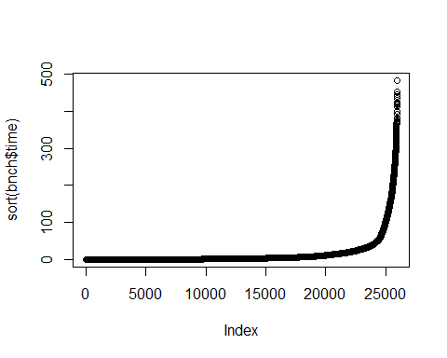

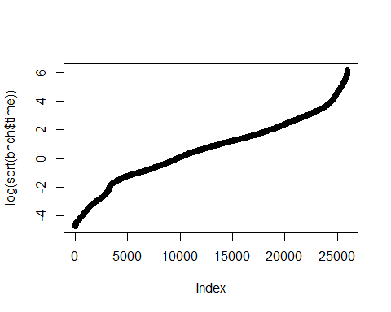

| **Characteristic** | **100**, N = 5,760*1* | **200**, N = 5,760*1* | **1000**, N = 4,320*1* | **2000**, N = 4,320*1* | **10000**, N = 2,880*1* | **20000**, N = 2,880*1* |
| --- | --- | --- | --- | --- | --- | --- |
| Algorithm |  |  |  |  |  |  |
| Naive | 960 (17%) | 960 (17%) | 720 (17%) | 720 (17%) | 480 (17%) | 480 (17%) |
| Hash | 960 (17%) | 960 (17%) | 720 (17%) | 720 (17%) | 480 (17%) | 480 (17%) |
| Threshold | 3,840 (67%) | 3,840 (67%) | 2,880 (67%) | 2,880 (67%) | 1,920 (67%) | 1,920 (67%) |
| Additional candidate matches proportion |  |  |  |  |  |  |
| 0.1 | 1,440 (25%) | 1,440 (25%) | 1,440 (33%) | 1,440 (33%) | 1,440 (50%) | 1,440 (50%) |
| 2 | 1,440 (25%) | 1,440 (25%) | 1,440 (33%) | 1,440 (33%) | 1,440 (50%) | 1,440 (50%) |
| 10 | 1,440 (25%) | 1,440 (25%) | 1,440 (33%) | 1,440 (33%) | 0 (0%) | 0 (0%) |
| 100 | 1,440 (25%) | 1,440 (25%) | 0 (0%) | 0 (0%) | 0 (0%) | 0 (0%) |
| Threshold to use |  |  |  |  |  |  |
| 1 | 960 (25%) | 960 (25%) | 720 (25%) | 720 (25%) | 480 (25%) | 480 (25%) |
| half | 960 (25%) | 960 (25%) | 720 (25%) | 720 (25%) | 480 (25%) | 480 (25%) |
| max | 960 (25%) | 960 (25%) | 720 (25%) | 720 (25%) | 480 (25%) | 480 (25%) |
| double | 960 (25%) | 960 (25%) | 720 (25%) | 720 (25%) | 480 (25%) | 480 (25%) |
| Unknown | 1,920 | 1,920 | 1,440 | 1,440 | 960 | 960 |
| Matching rules and Variable distributions |  |  |  |  |  |  |
| Age exact + Uniform | 1,920 (33%) | 1,920 (33%) | 1,440 (33%) | 1,440 (33%) | 960 (33%) | 960 (33%) |
| Age +=1 + Uniform | 1,920 (33%) | 1,920 (33%) | 1,440 (33%) | 1,440 (33%) | 960 (33%) | 960 (33%) |
| Age exact + Normal | 1,920 (33%) | 1,920 (33%) | 1,440 (33%) | 1,440 (33%) | 960 (33%) | 960 (33%) |
| Sampling of candidate matches and bootstrap schema |  |  |  |  |  |  |
| Sample 1 cm to each exposed | 1,440 (25%) | 1,440 (25%) | 1,080 (25%) | 1,080 (25%) | 720 (25%) | 720 (25%) |
| Take all cm to each exposed | 1,440 (25%) | 1,440 (25%) | 1,080 (25%) | 1,080 (25%) | 720 (25%) | 720 (25%) |
| Sample 1 cm to each exposed and take 10 bootstrap sampling from the exposed | 1,440 (25%) | 1,440 (25%) | 1,080 (25%) | 1,080 (25%) | 720 (25%) | 720 (25%) |
| Sample 1 cm to each exposed and take 10 bootstrap sampling from all UoO | 1,440 (25%) | 1,440 (25%) | 1,080 (25%) | 1,080 (25%) | 720 (25%) | 720 (25%) |
| Number of cores used |  |  |  |  |  |  |
| Use 1 thread | 2,880 (50%) | 2,880 (50%) | 2,160 (50%) | 2,160 (50%) | 1,440 (50%) | 1,440 (50%) |
| Use half the threads present in the CPU | 2,880 (50%) | 2,880 (50%) | 2,160 (50%) | 2,160 (50%) | 1,440 (50%) | 1,440 (50%) |
| *1*n (%) | | | | | | |

## Table 1 metrics

| **Characteristic** | **100**, N = 5,760 | **200**, N = 5,760 | **1000**, N = 4,320 | **2000**, N = 4,320 | **10000**, N = 2,880 | **20000**, N = 2,880 |
| --- | --- | --- | --- | --- | --- | --- |
| Time (s) (Min, Max) | 0 / 25 | 0 / 57 | 0 / 194 | 0 / 332 | 0 / 383 | 0 / 483 |
| Time (s) (25%, Median, 75%) | 0 / 1 / 3 | 0 / 1 / 5 | 0 / 3 / 12 | 1 / 3 / 15 | 2 / 6 / 27 | 4 / 9 / 33 |
| Time (s) (Mean, SD) | 3 / 4 | 5 / 8 | 13 / 28 | 19 / 40 | 31 / 62 | 37 / 72 |
| Memory allocation (MB) (Min, Max) | 1 / 513 | 1 / 1,345 | 2 / 3,002 | 2 / 5,843 | 17 / 9,772 | 61 / 18,996 |
| Memory allocation (MB) (25%, Median, 75%) | 7 / 18 / 56 | 8 / 26 / 89 | 14 / 51 / 203 | 23 / 74 / 269 | 116 / 324 / 740 | 327 / 775 / 1,719 |
| Memory allocation (MB) (Mean, SD) | 45 / 74 | 84 / 164 | 211 / 441 | 333 / 764 | 818 / 1,516 | 1,735 / 2,834 |
| Secondary memory usage (KB) (Min, Max) | 0 / 358 | 1 / 655 | 5 / 1,950 | 13 / 2,755 | 79 / 4,737 | 156 / 8,230 |
| Secondary memory usage (KB) (25%, Median, 75%) | 9 / 23 / 62 | 14 / 40 / 114 | 59 / 117 / 330 | 120 / 237 / 512 | 667 / 1,025 / 1,801 | 1,320 / 2,687 / 3,758 |
| Secondary memory usage (KB) (Mean, SD) | 55 / 79 | 97 / 142 | 286 / 425 | 449 / 588 | 1,368 / 1,070 | 2,691 / 1,875 |

## Algorithm

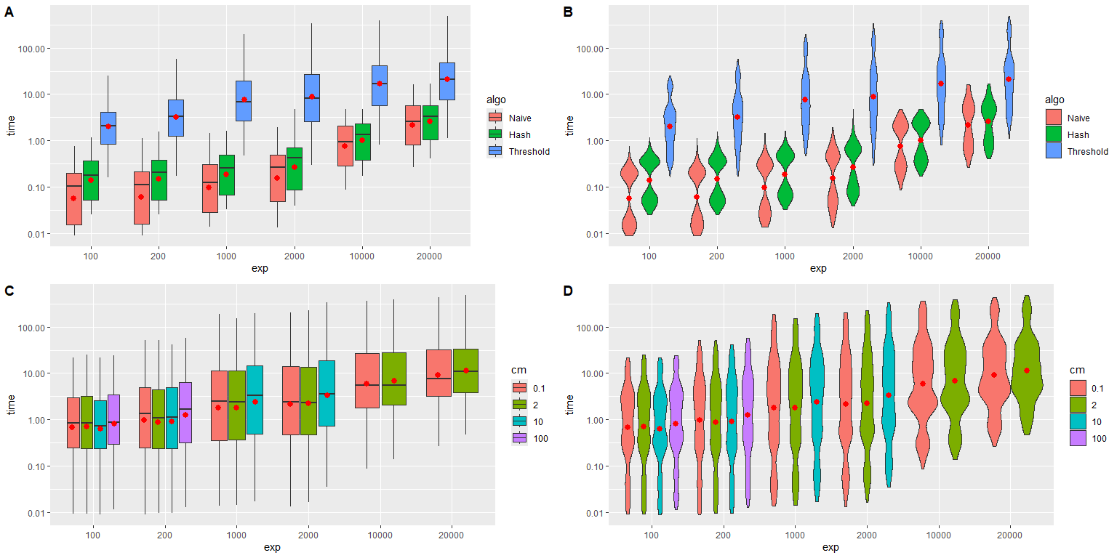

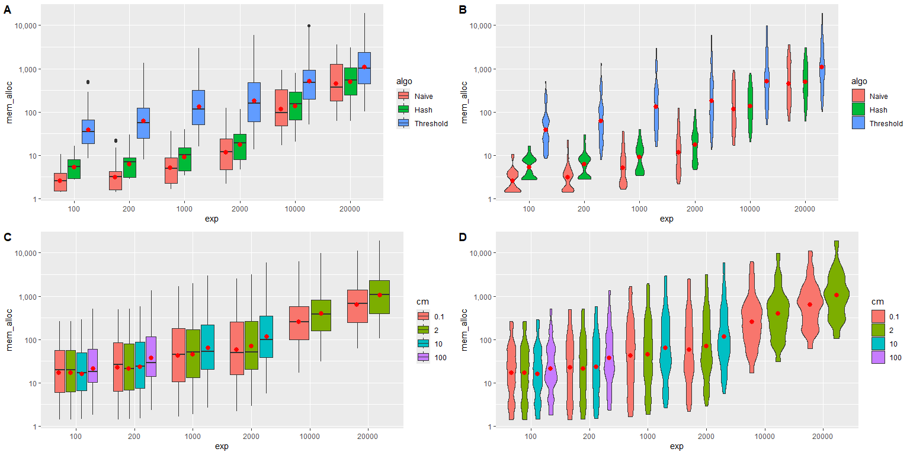

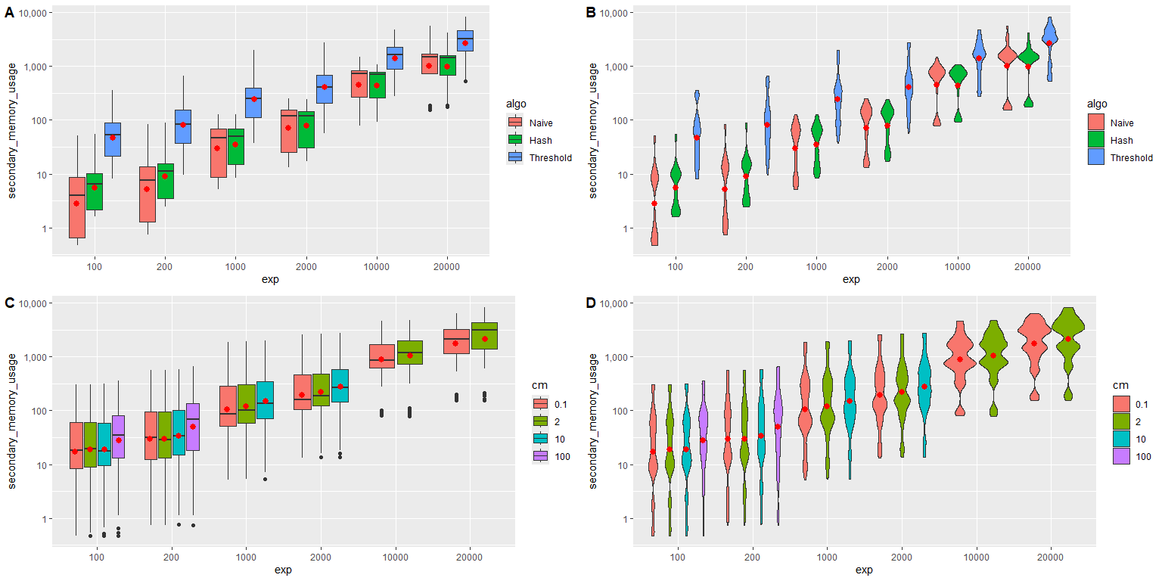

## Candidate matches

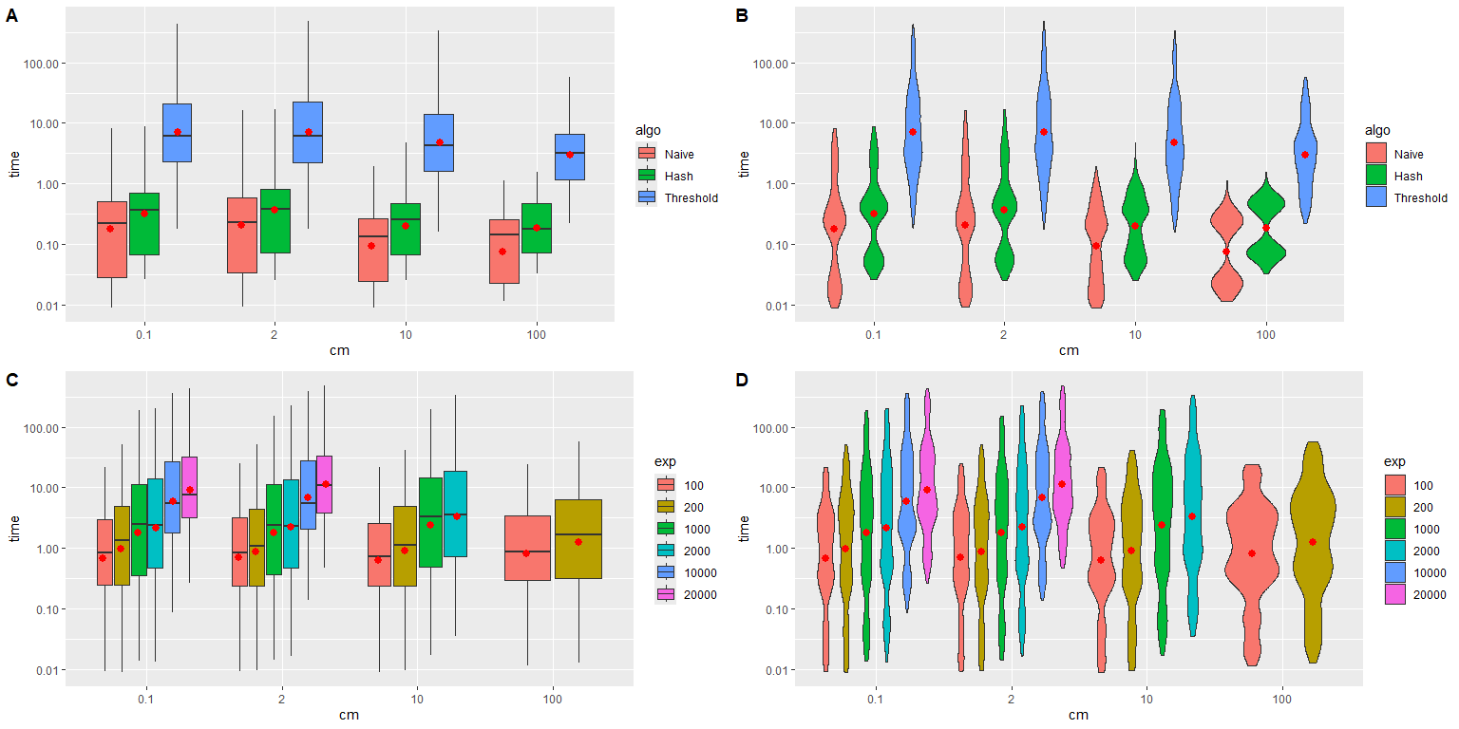

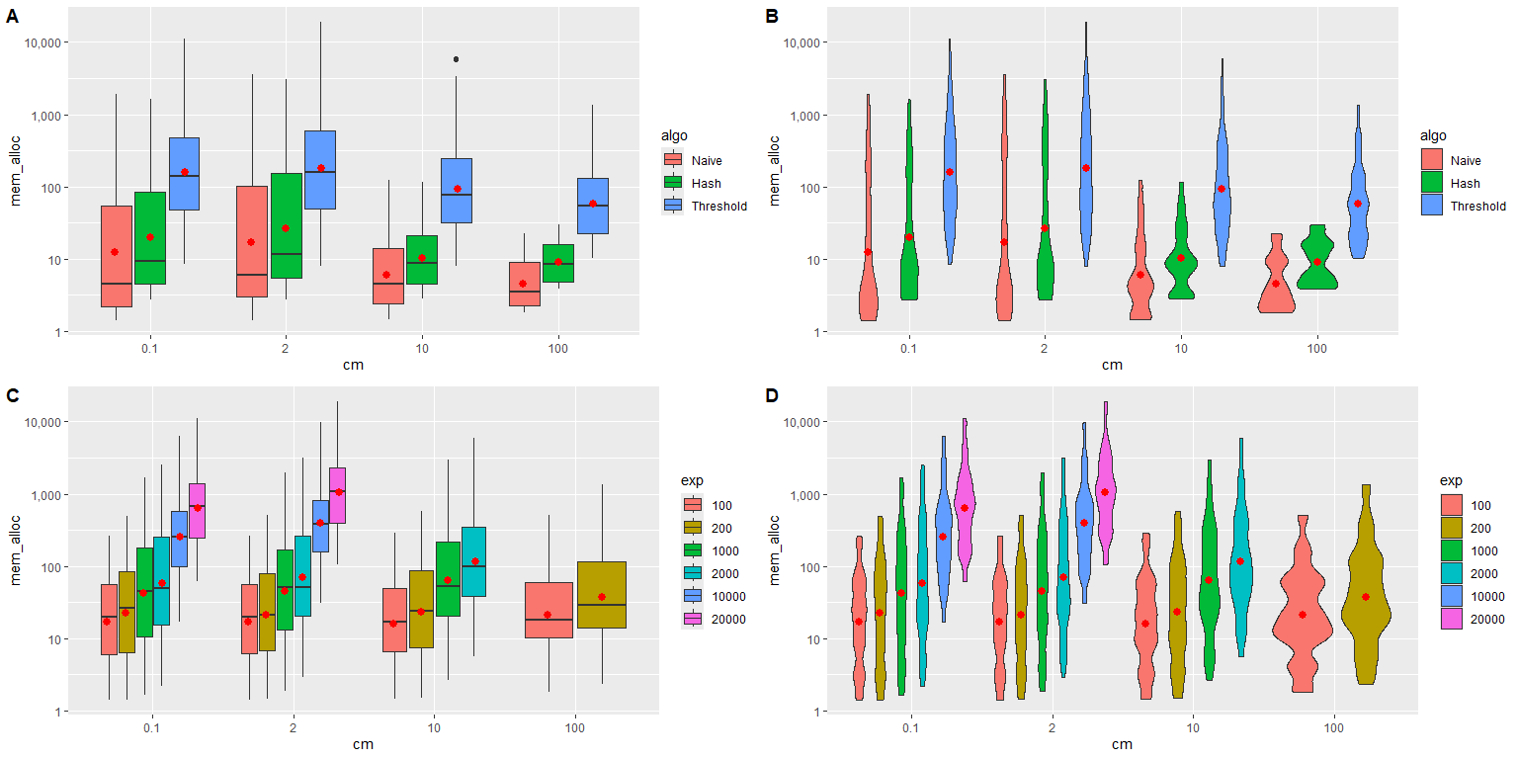

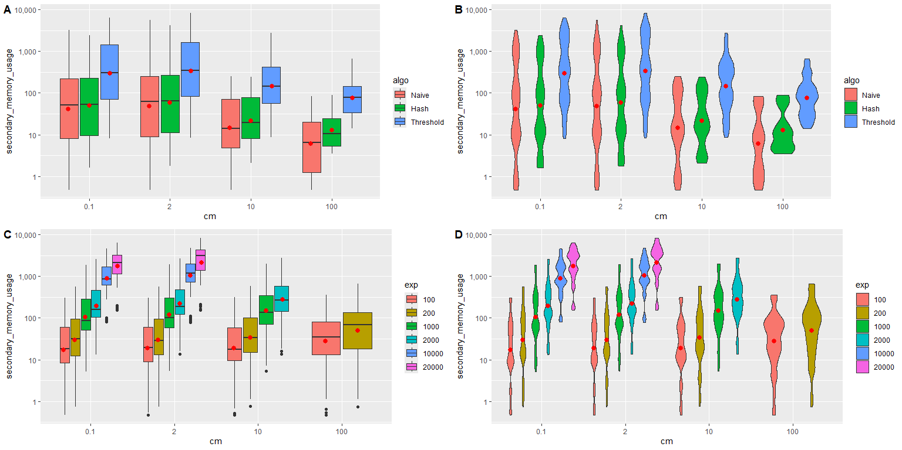

## Threshold to use

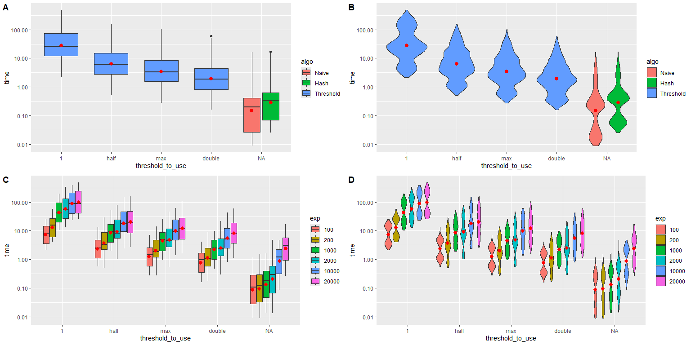

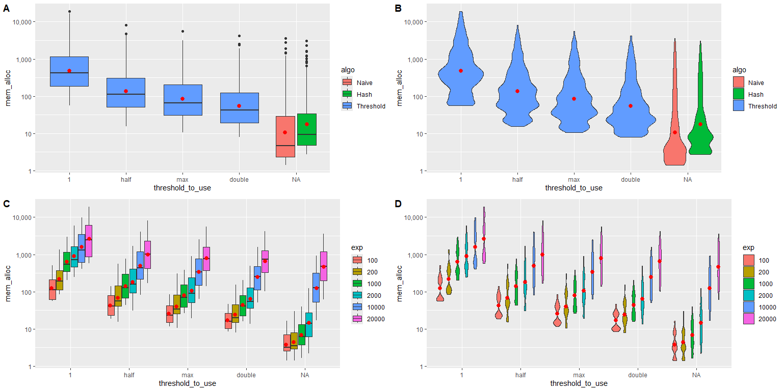

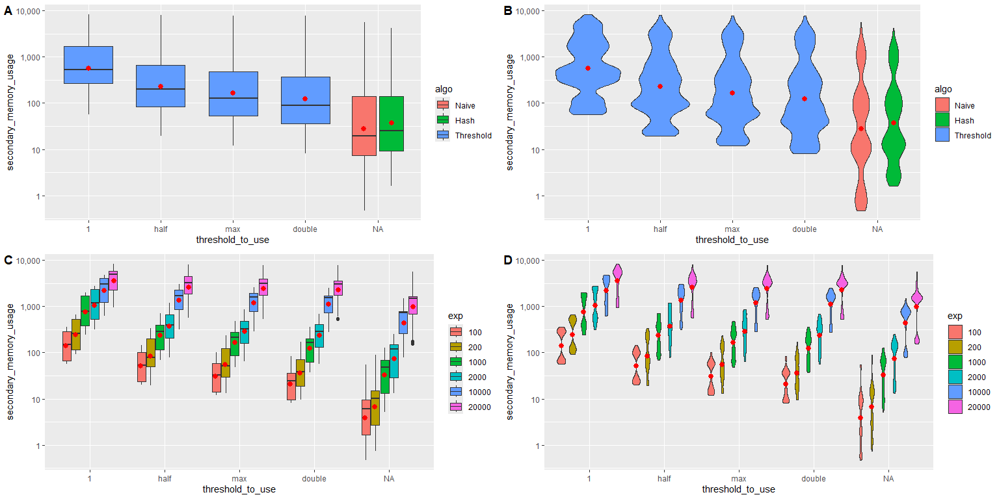

## Matching rules and Variable distributions

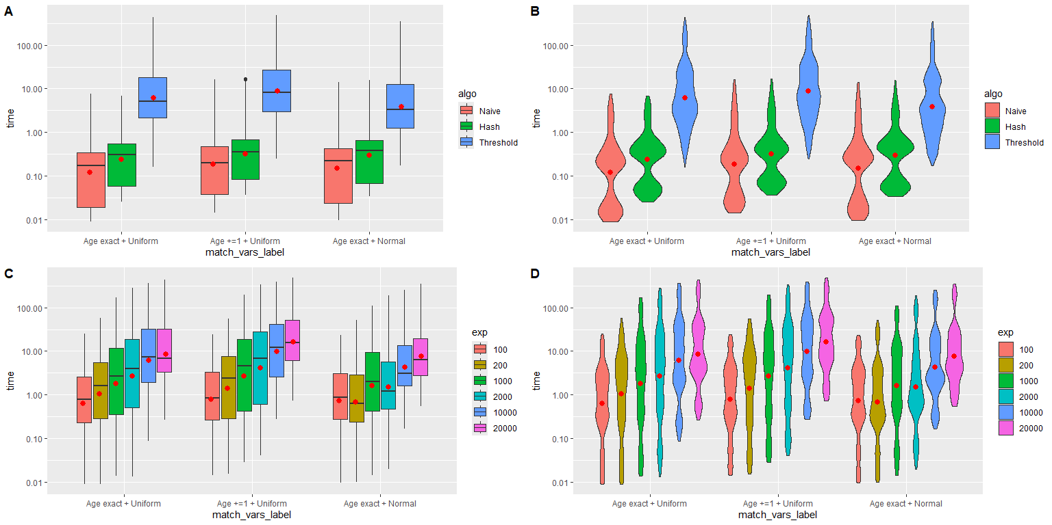

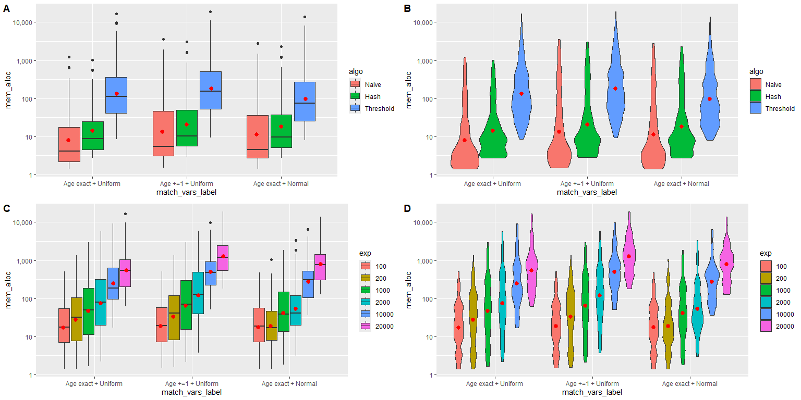

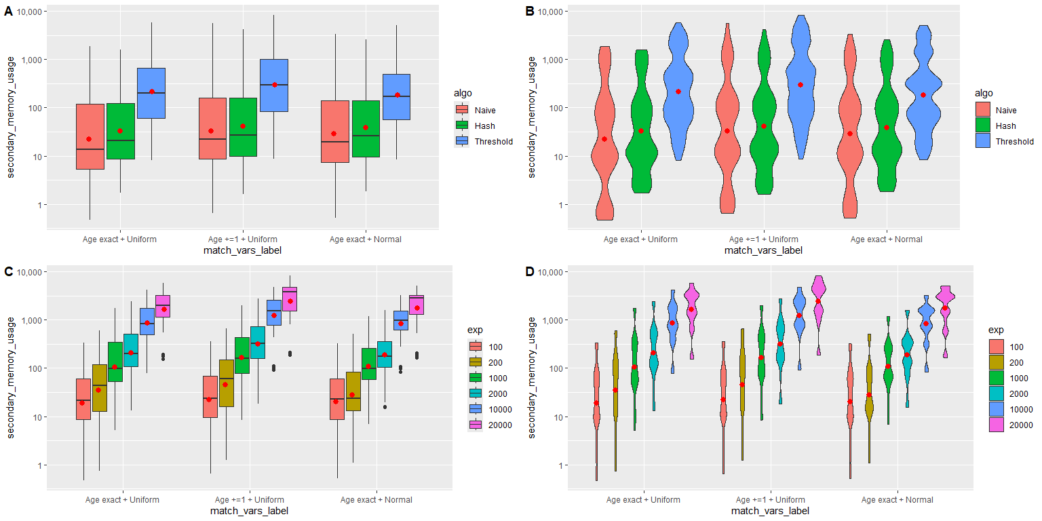

## Sampling of candidate matches and bootstrap schema

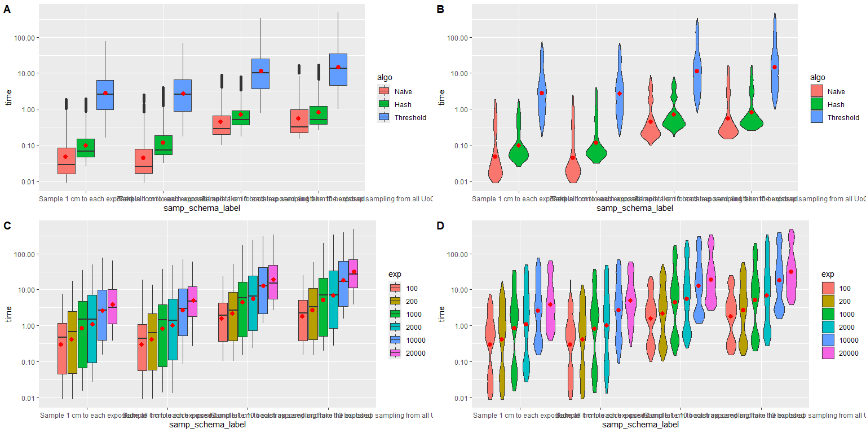

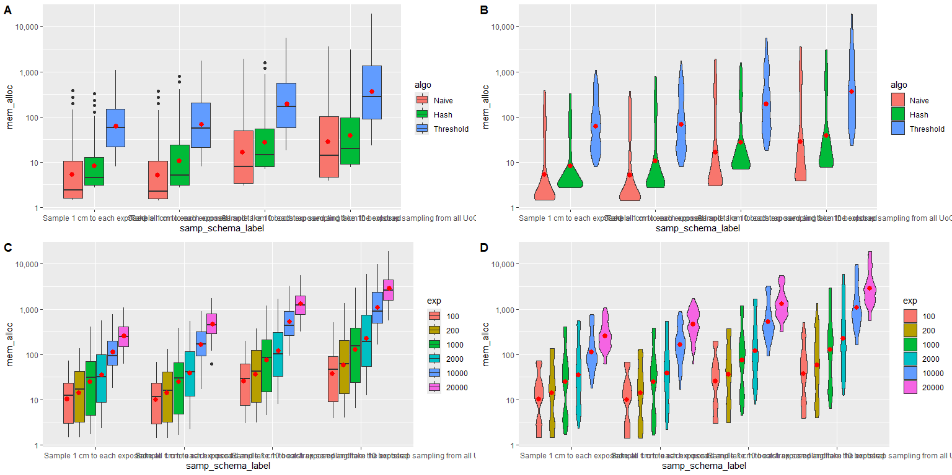

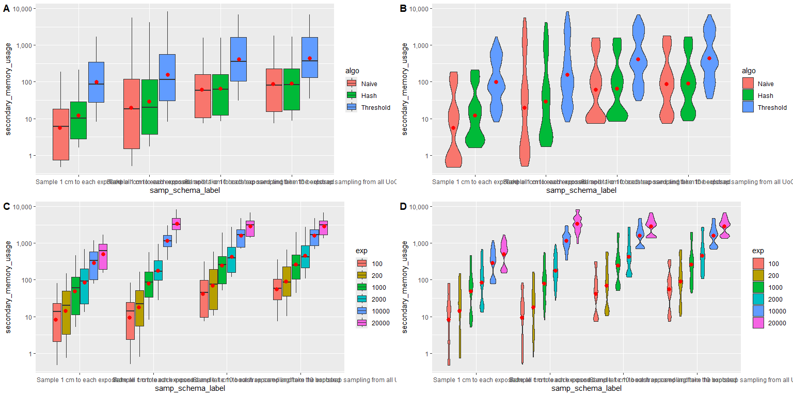

## Number of cores used

